Day 1 Lab Assignments
- Create no-standalone project.

- Create the following components, and add them to your root component:
  - The components structure should be as the following:
    - App Component (Root Component)
      - Header
      - Products
      - Footer
  - Component named header, that will be displayed in page header, which has:
    - Bootstrap responsive navbar.
      - Add bootstrap install and link in style.css file
    - Photo banner
      - Add it in the assets folder, and then display it under the navbar
  - Component named footer, and display it in the page footer.
  - Component named Products to be displayed in the body, make it empty for now.
  - Add new component (SideMenu) besides the Product component (With any dummy content or image).
  - The Page layout should be as the following:
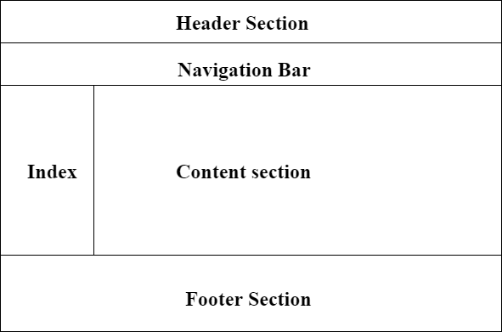
  - Review the app.module, and see how the components you created were added in imports and in declaration in @ngmodule decorator function.
- Create New folder in the app folder (Name it: Models), and create the following inside it:
  - Class Store, has properties:
    - Name
    - Array of branches
    - Logo
  - Enum named DiscountOffers with values: (“No Discount”, “10%”, “15%”). [Bonus]

- In the product component:
  - In the Component class, add the following properties:
      - Property “Discount” of type DiscountOffers Enum. [Bonus]
      - Object of Store class.
      - Propery “ClientName” of type string.
  - In the Component HTML:
      - <h1> tag to display store name (Use angular Expression {{}}).
      - <img> tag to display store logo .

